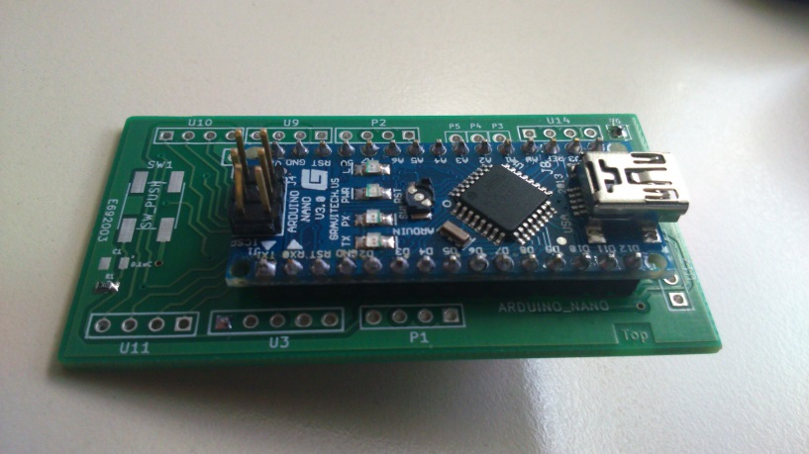
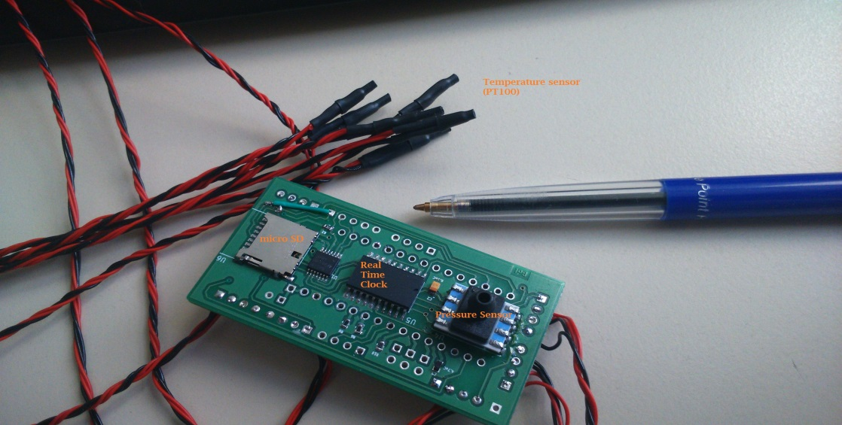
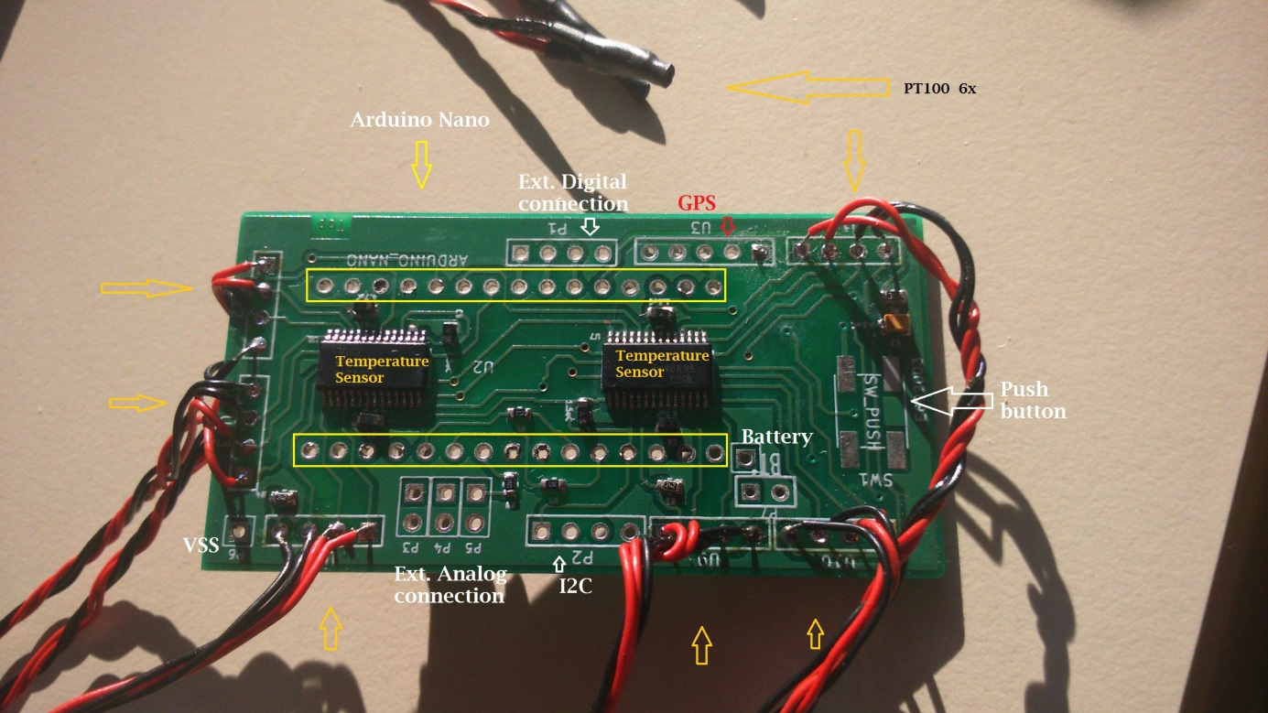
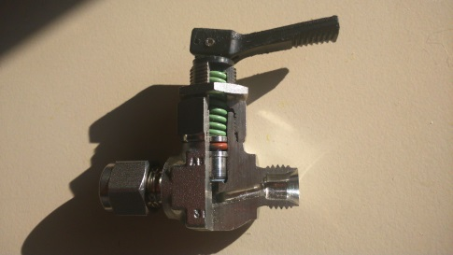
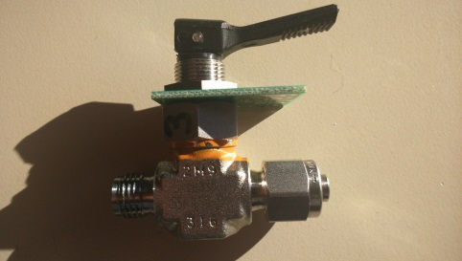
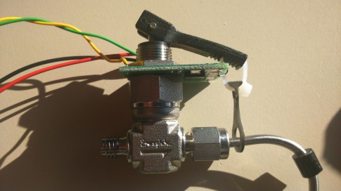
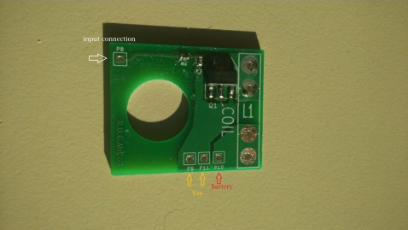
Datalogger AirPack RUG
The data logger is designed and made in-house at the Center for Isotope Research of the University of Groningen to ease the use of our AirPack system. It logs temperature, pressure, and GPS information, and controls an automatic valve through a digital I/O. The data logger is based on the Arduino Nano, and collects data during AirPack flight onto a micro SD card.
Figure 1 Datalogger AirPack

The data logger functions in a number of ways during flight:
- Sending a signal to the automatic valve to close the open end of the AirPack shortly (~10 seconds) after landing, shown in figure xx6, described in the section below. The data logger uses the pressure measurement or/and GPS location to determine when to send the valve-closing signal. Both can be used, for the Pressure measurement, a pressure sensor is placed on the board. And for the GPS, an external connection is made for connecting the GPS module. The GPS module can also be used for logging the Position of the AirPack.
- Logging temperatures of the AirPack at up to 6 different places. To know when the measurement has been done, there is a real time clock on board. This clock will give the date and time, which can be programmed.
- There are also possibilities to connect devices on a I²C bus or SPI bus (max. 3). If the three digital I/O pin aren’t used for the SPI bus, then these pins can be used as digital I/O pin. For example: to give a pulse to activate the automatic valve. When the I²C connection is not used, then these two pins can be used as analog I/O pins. The board has also an extra three analog I/O pins for reading or writing an analog signal. For example to activate a radiometrix.

- - Bottom of the D.A.R. - -
Figure 2 Bottom of datalogger
Real time measurement.
The time measurement is done with the real time IC DS3234 from Dallas semiconductors. The IC is an extremely accurate SPI bus RTC. The IC will be communicated and programmed through SPI bus with the Arduino. The time and date will be logged : DD-MM-YY HH:MM:SS.
Pressure measurements.
The Pressure measurement is done with the Honeywell TruStability HSC Silicon Pressure Sensor. Pressure sensor is used for detecting landing and communicated with PSI bus. Accuracy ±0.25% and pressure range 0-15 PSI.
Servo Control
The Pack are open and closed by a Servo. The Servo are connected to the P1, P3,P4 and P5. on the datalogger. The servo's can turn 0-180 degeer and are controlled by PWM.
Micro SD card.
The data will be logged on a micro SD card. The communication is done with the SPI bus.
Battery
The datalogger can be supplied by a dc power supply from 6 till 20 volts. The type of battery is depending on the use for the datalogger. For an airpack flight, the power supply is a 24 volt (2*12V or 8*3V)battery, that is used for the automatic pump. For the Datalogger, there is 12V or 6V(2*3V) adapter form the 24V power supply.

- - Top of the D.A.R - -
Figure 3 Top of the datalogger
Temperature measurement.
The temperature measurement is done with the IC ADS1248, 24-bit Analog-to-Digital Converters for Temperature Sensors. There are 6 places on the board to connect a PT100 sensor to measure the coil temperature. The measurement is done by a three (four) point measurement, because of this method, there can only be 3 sensors on one IC. For 6 sensors, there are two IC on board. The communication of the IC is done with the SPI bus. The sensor is the world´s smallest platinum thin-film temperature sensor from Innovative Sensor Technology. Tolerance class A (0. 15°C)
GPS connection
The GSP sensor can be connected to P1, the serial bus connection of the board.
Ext. I²C connection.
Several devices, that communicate with an I²C bus can be connected to P2. P2 is an I²C bus connection.
Ext. connection
There are three analog connection (P3, P4 and P5) on the board, they can be used as analog input or output. 10 bit resolution.
On the board are also three digital i/o connection (P1). These pins can be used for extra connections on the SPI bus, active the automatic value with one external interrupt or input ready sensor.
SW-Push is space for a push button, this can be used for example to activate the data logger.

Automatic valve
Figure 4 Open valve
Figure 5 Valve: closed
Figure 6 Valve: open
Figure 7 PCB of the automatic valve
The board for the automatic valvue is based on a 9 Volt battery and a digital input. The automatic valve used about 1A for a few seconds, depending of the thickness of the cable tie.

Datalogger 1
Datalogger is used for :
- Aircoire 1 [Sold to Germany]
On board, there is :
- Automatic Valve
- Micro SD Card
- External Power Supply
- Pressure Sensor
- Real Time Clock
- Temperature Sensor 1..3
- Temperature Sensor 4..6

Datalogger 2
Datalogger is used for :
- Aircoire 2 [Sold to Germany]
On board, there is :
- Automatic Valve
- Micro SD Card
- External Power Supply
- Pressure Sensor
- Real Time Clock
- Temperature Sensor 1..3
- Temperature Sensor 4..6

Datalogger 3
Datalogger is used for :
- Aircoire 3 [used in Finland]
On board, there is :
- Automatic Valve
- Micro SD Card
- External Power Supply
- Pressure Sensor
- Real Time Clock
- Temperature Sensor 1..3
- Temperature Sensor 4..6

Datalogger 4
Datalogger is used for :
- Aircoire 4 [Used in Finland]
On board, there is :
- Automatic Valve
- Micro SD Card
- External Power Supply
- Pressure Sensor
- Real Time Clock
- Temperature Sensor 1..3
- Temperature Sensor 4..6

Datalogger 5
Datalogger is used for :
- Testing
On board, there is :
- Can be all or nothing.

Datalogger
Datalogger is used for :
- Aircore 6 [used for Truls-Drone]
On board, there is :
- Automatic Valve
- Micro SD Card
- External Power Supply
- Pressure Sensor
- Real Time Clock
- Temperature Sensor 1..3
- [Optional] Temperature Sensor 4..6
- GPS module
- External Pressure Sensor
- Start Pump
- CH4 Sensor
- Humidity and Temperature Sensor.

Datalogger
Datalogger is used for :
- Aircore 7 [used for Truls-Drone]
On board, there is :
- Automatic Valve
- Micro SD Card
- External Power Supply
- Pressure Sensor
- Real Time Clock
- Temperature Sensor 1..3
- [Optional] Temperature Sensor 4..6
- GPS module
- External Pressure Sensor
- Start Pump
- CH4 Sensor
- Humidity and Temperature Sensor.

Datalogger
Datalogger is used for :
- Aircore 8 [used for Wessel-Datalogger]
On board, there is :
- Micro SD Card
- External Power Supply
- Pressure Sensor
- Real Time Clock
- Temperature Sensor 1..3
- [Optional] Temperature Sensor 4..6
- GPS module
- External Pressure Sensor
- Start Pump
- CH4 Sensor
- Humidity and Temperature Sensor.

Datalogger
Datalogger is used for :
- AirPack 9 [used for Bag-Datalogger]
On board, there is :
- Micro SD Card
- External Power Supply
- Pressure Sensor
- Real Time Clock
- Temperature Sensor 1..3
- [Optional] Temperature Sensor 4..6
- GPS module
- Start Pump
- Close/Open Bag [1..4]

Datalogger
Datalogger is used for :
- AirPack 10 [used for Bag-Datalogger]
On board, there is :
- Micro SD Card
- External Power Supply
- Pressure Sensor
- Real Time Clock
- Temperature Sensor 1..3
- [Optional] Temperature Sensor 4..6
- GPS module
- Start Pump
- Close/Open Bag [1..4]

